**Power BI –**

**Assignment #2 by Ahmed Magdy**

**Dated: 30 December 2021**

Return to the REPORT view, and complete the following:

Edit (or insert) the matrix visual to show ReturnQuantity (values) by CategoryName (rows) from the AW_Product_Category_Lookup table

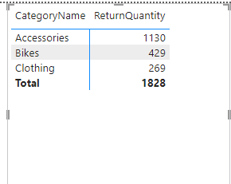

• Which category saw the highest volume of returns? How many?



Replace CategoryName with Year from the AW_Calendar_Lookup table

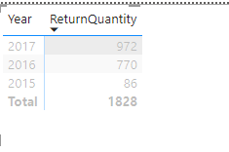

How many returns do you see in 2015 vs. 2016?

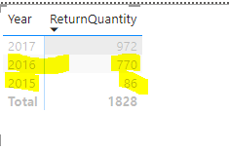

Replace Year with FullName from the AW_Customer_Lookup table

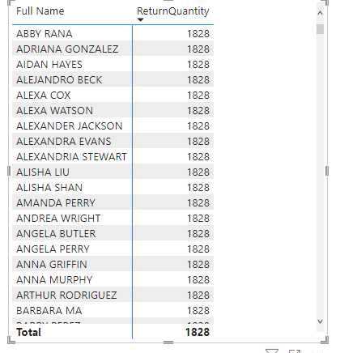

• What do you see, and why?

Return quantity is repeated for full name, as there is no relationship between these two fields/tables , that’s why.

Update the matrix to show both OrderQuantity and ReturnQuantity (values) by ProductKey (rows) fro m the AW_Product_Lookup table

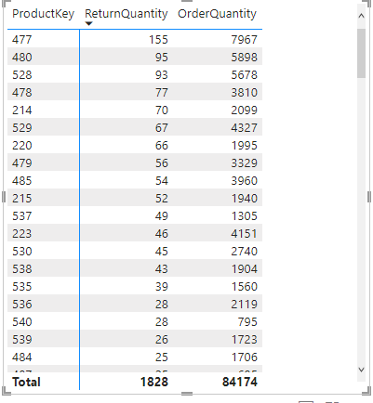

What was the total OrderQuantity for Product #338?



Unhide the ProductKey field from the AW_Returns tables (using either the DATA or RELATIONSHIPS view): • In the matrix, replace ProductKey from AW_Product_Lookup with ProductKey from the AW_Returns table

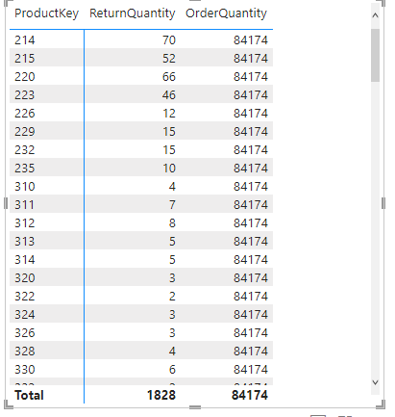

• Why do we the same repeating values for OrderQuantity?

**Because Productkey under returnrs table is not the lookup field.**

Edit the relationship between AW_Returns and AW_Product_Lookup to change the cross filter direction from Single to Both

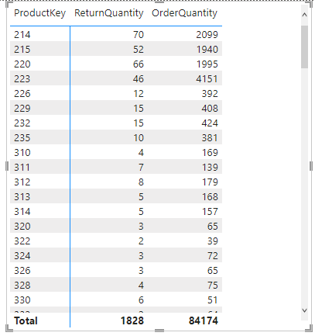

How many orders do we see now for Product #338? What's going on here?

NONE;

Change the cross filter direction between AW_Returns and AW_Product_Lookup back to single (OneWay)

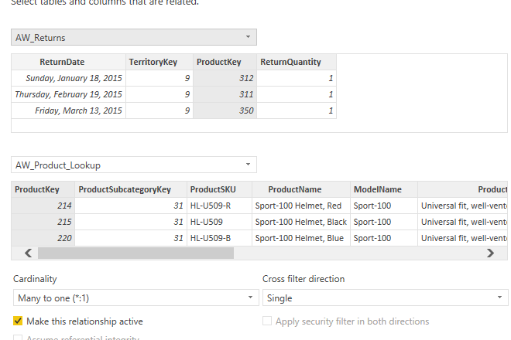

Hide the ProductKey field in the AW_Returns table from report view (and any other foreign keys, if necessary)

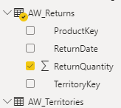

Update the matrix to show ProductKey from the AW_Product_Lookup, rather than AW_Returns

